**Presentation**

**Coursera Capstone Project - The Battle of the Neighborhoods**

**-- A Survey of the Mexican Restaurants in New York City --**

**Robert Gray**

**The best Mexican restaurants in New York City…**

**…What boroughs?**

**…What neighborhoods?**

**…Which restaurants are the absolute best?**

**… What is the best place to open a new Mexican restaurant?**

**Using the geographic data from here:**

[**https://cocl.us/new_york_dataset**](https://cocl.us/new_york_dataset)

**And using the Foursquare API, we can see the best NYC boroughs, neighborhoods for the best Mexican restaurants. We can use this data to pick a great spot for a new Mexican restaurant.**

**Here’s what we found!**

**Where Mexican restaurants are in NYC:**

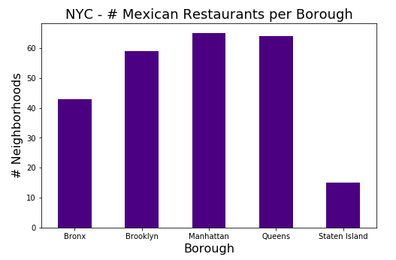

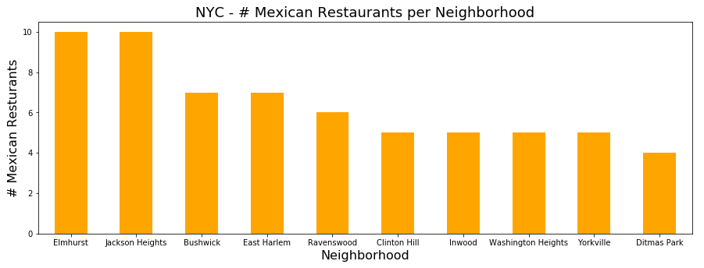

**The names of those restaurants in the top neighborhoods…**

#### Elmhurst:

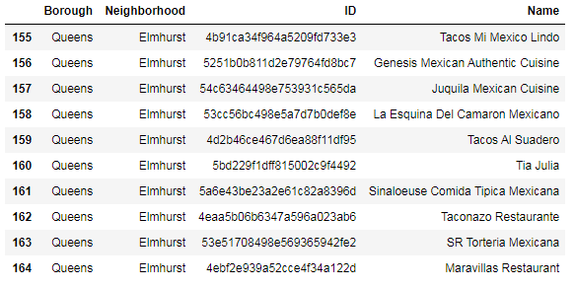

#### Jackson Heights:

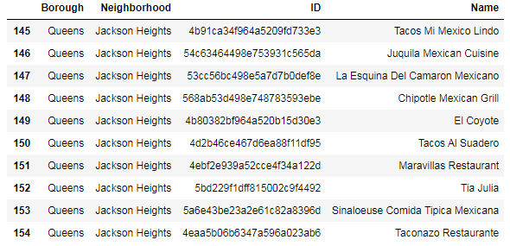

**Which boroughs have the highest ratings?**

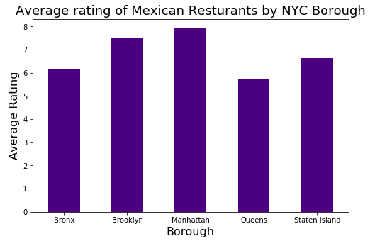

**Which neighborhoods have the highest ratings?**

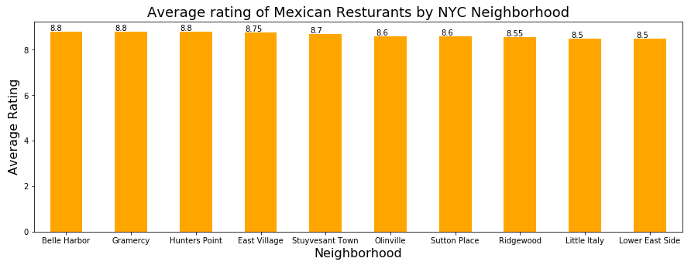

**Which individual Mexican restaurant in NYC has the highest rating?**

Borough Queens

Neighborhood Ridgewood

Name Taquerias Kermes

Likes 50

Rating 9.1

Tips 28

**Which individual Mexican restaurant in NYC has the most likes?**

Borough Manhattan

Neighborhood Little Italy

Name La Esquina

Likes 1991

Rating 8.5

Tips 720

**Which NYC neighborhoods have average Mexican restaurant ratings of 8.0 and above?**

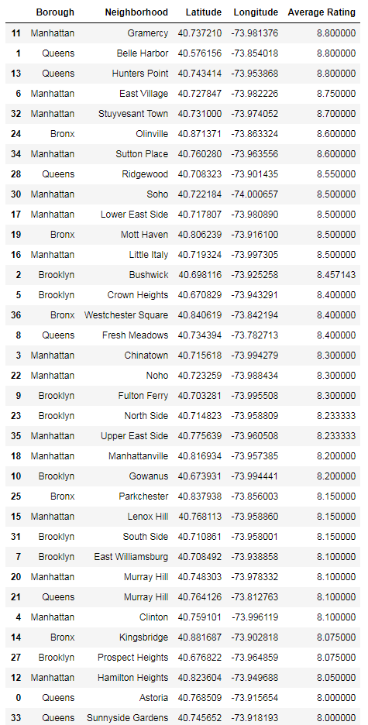

## Final Results!

### Borough: We have Manhattan as the Borough with the highest average rating (7.92).

### Neighborhood: We have Belle Harbor (in Queens), Grammercy (in Manhattan), and Hunter's Point (in Queens) tied as the Neighborhoods with the highest average rating (8.8).

### Restaurant: We have Taquerias Kermes as the Restaurant with the highest rating (9.1). Borough: Queens, Neighborhood: Ridgewood

### Restaurant: We have La Esquina as the Restaurant with the most likes (1,991). Borough: Manhattan, Neighborhood: Little Italy

Below is the data plus a geographical plot of these 8.0+ rated Mexican restaurants in NYC.

Take this with you the next time you visit New York City!!



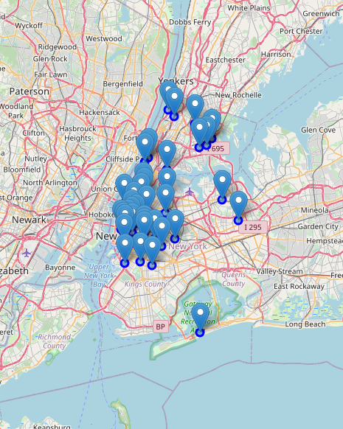

### The best NYC borough for Mexican restaurants:¶

I would recommend Manhattan as the best boroughs for Mexican food in New York City. Manhattan has the least number of neighborhoods, but the most Mexican restaurants. Queens has the second most restaurants, and Queens has some of the top-rated restaurants, however Queens has an average rating of only 5.7, while Manhattan has an overall rating of 7.9. Brooklyn has the third most Mexican restaurants, and has an average rating of 7.5, so I would recommend Brooklyn as the second best borough after Manhattan for Mexican restaurants.

**Where to start a new Mexican restaurant.**

If I were to open a new Mexican restaurant in New York City, I'd choose the Gramercy neighborhood in Manhattan. It has the highest average rating for Mexican restaurants, so there's a demand there and people are used to going there for great Mexican food. With that sort of draw, I believe people would give new Mexican restaurant a chance there!

**How did I get all of this? By using DATA SCIENCE!!**

**See you in the next Coursera class!!**